**Software Requirements Specification**

**for**

**Discord Gameplay Plugin**

**Version 1.0 approved**

**Prepared by Maddie Zakham, Jason Kotowski**

**Dyno Discordance Group**

**10/2/2022**

## Introduction

#### Purpose

The purpose of this plugin is to be able to track gameplay content and other information and save it to our Discord profiles. This content includes gameplay hours, achievements, ratings and more. This way, each Discord user can share their ratings and content in Discord servers as well as track their own gameplay for personal use. With the use of this plugin, players can be more engaged in their gameplay and more interactive with their friends on discord. All a player needs is a Steam account to play their games and a Discord account to link together and share info.

#### Operating Environment

As of now, the application will function as a desktop-exclusive plugin. Firstly, it requires the most up-to-date version of Discord, as it utilizes its API for many features. Secondly, it also requires Steam with actively installed games in its library. The application needs to track what game is currently being played, as well as any achievements. The user must have the two accounts linked in order for the plugin to properly work. Expanding into utilizing other gaming platforms, such as The Epic Games Store, is a possible update in the foreseeable future, but it is out of scope for the current project.

#### Interfaces

The main interface of the program utilizes Discord’s messaging system. Discord already has a well-built interface for gaming and communication. For most interactions, the user will communicate to the application through a bot. The user will relay information in the form of bot commands in the lower textbox. The application will also allow pop-ups on the chat screen for the user to input simple information, such as ratings.

#### Program Requirements

###### Functional Requirements

* As a frequent gamer, I want the ability to track my gameplay hours on different Steam games.
* As a completionist, I want the ability to track my achievements on all of my Steam games.
* As a gamer, it would be cool to have a notification when I hit x hours in a game
* As a Discord server moderator, I want the ability to store game ratings and other info in Discord bots on my server.
* After I finish a gaming session, I want to be able to rate my play session.
* As someone who plays with friends often, I want to be able to send recommendations/ratings to friends on the games I play.
* When I’m looking for a game to purchase, I want to be able to command the bot to pull positive and negative reviews from the game’s Steam page.
* Someone with this plugin can invite people to play a game on the discord text chat
* As a avid player of a certain title, I want the ability to get notifications and track the game
* As someone who plays games on a low budget, I want to be notified when a game goes on sale.

###### Non-Functional Requirements

* As a player of Steam games, I want this plugin to support Steam games
* As a Discord user, I want this plugin to cooperate with Discord bots in servers.
* As a hardcore gamer, I want this plugin to be able to track gameplay of 100 or more games.
* As a discord server owner, I want the bots to be able to store data locally to each server.

#### Class Model

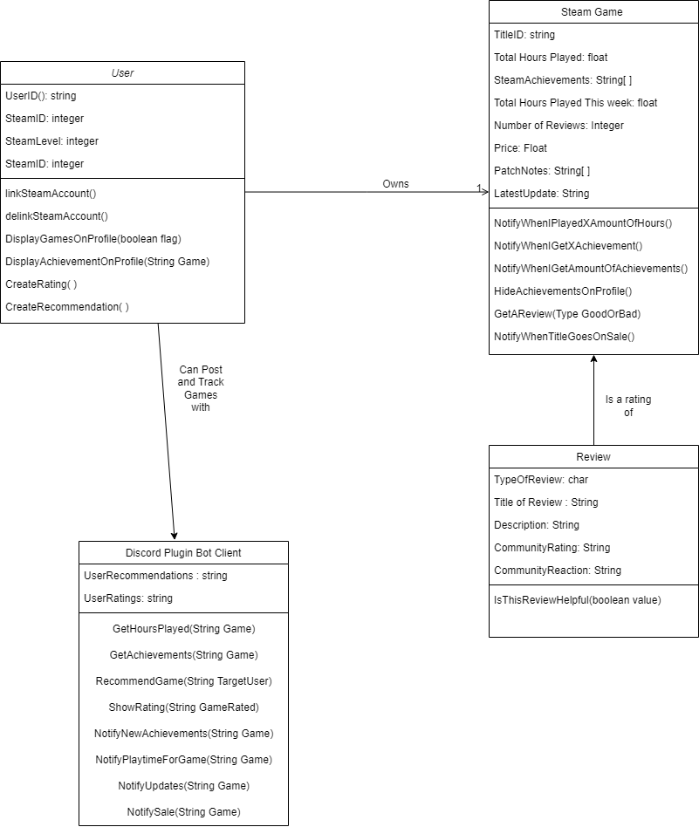

#### Behavioral Model

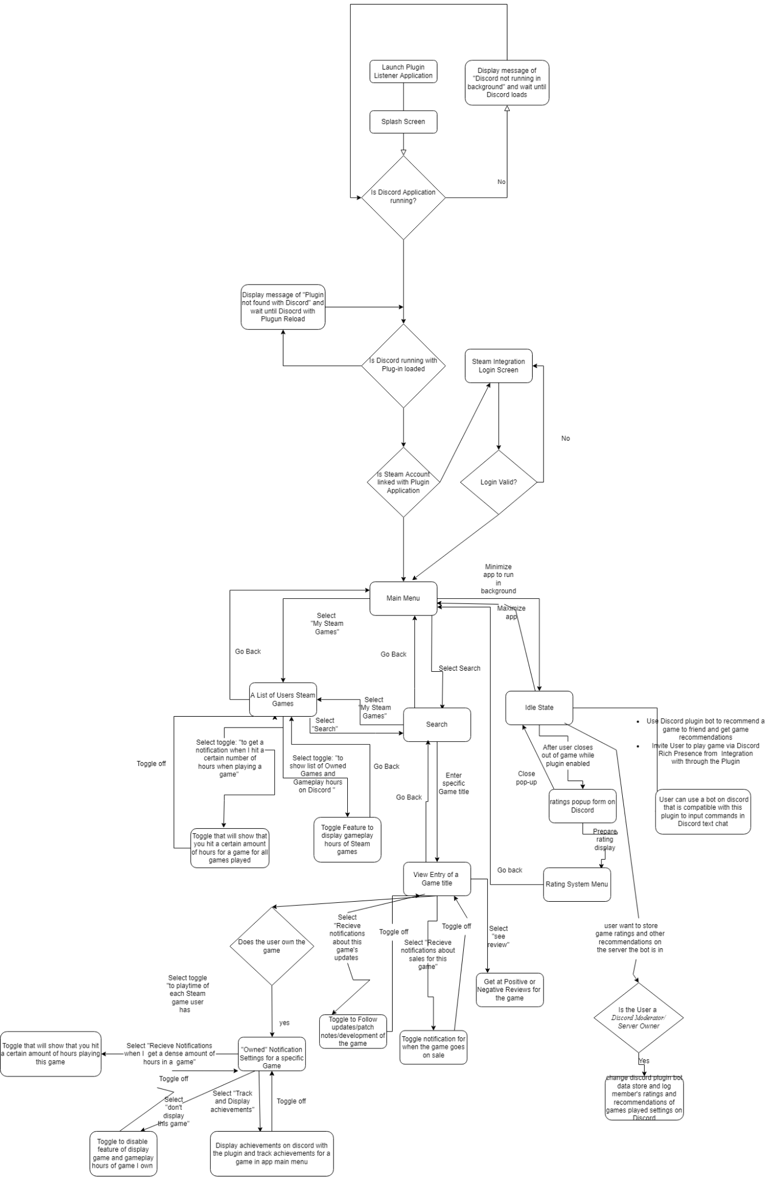

#### Requirement Models

* As a frequent gamer, I want the ability to track my gameplay hours on different Steam games.

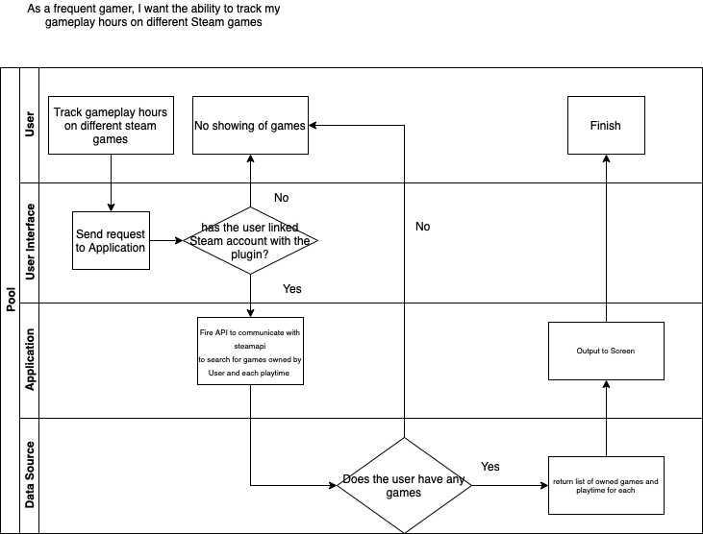

* As a completionist, I want the ability to track my achievements on all of my Steam games.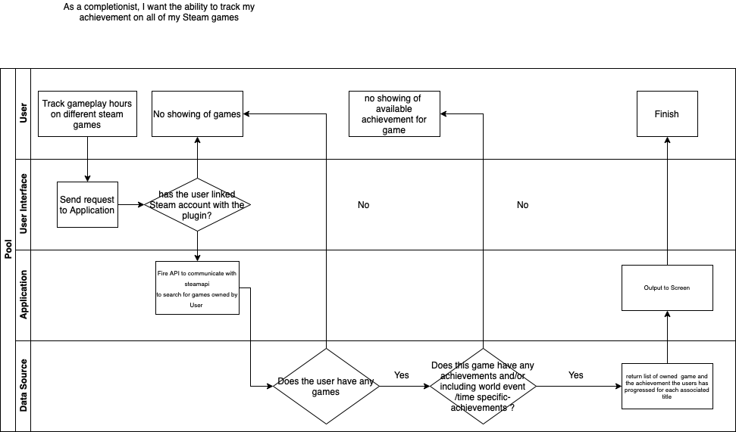
* As a gamer, it would be cool to have a notification when I hit x hours in a game

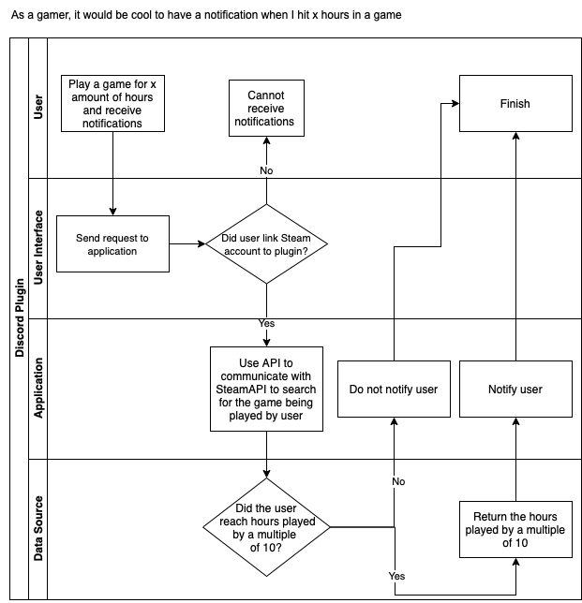

* As a Discord server moderator, I want the ability to store game ratings and other info in Discord bots on my server.

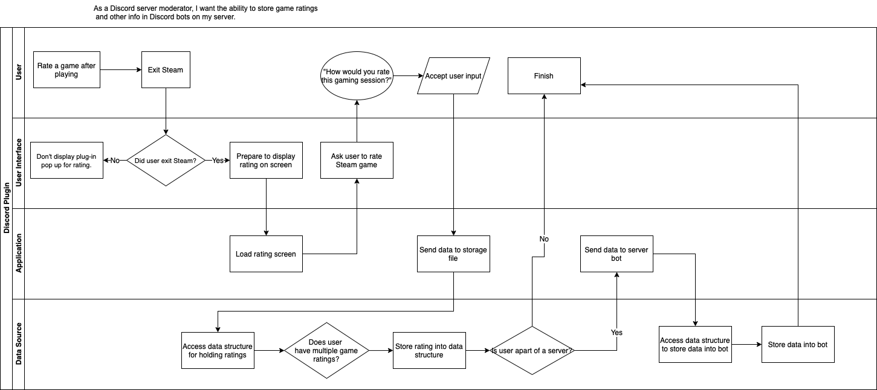

* After I finish a gaming session, I want to be able to rate my play session.

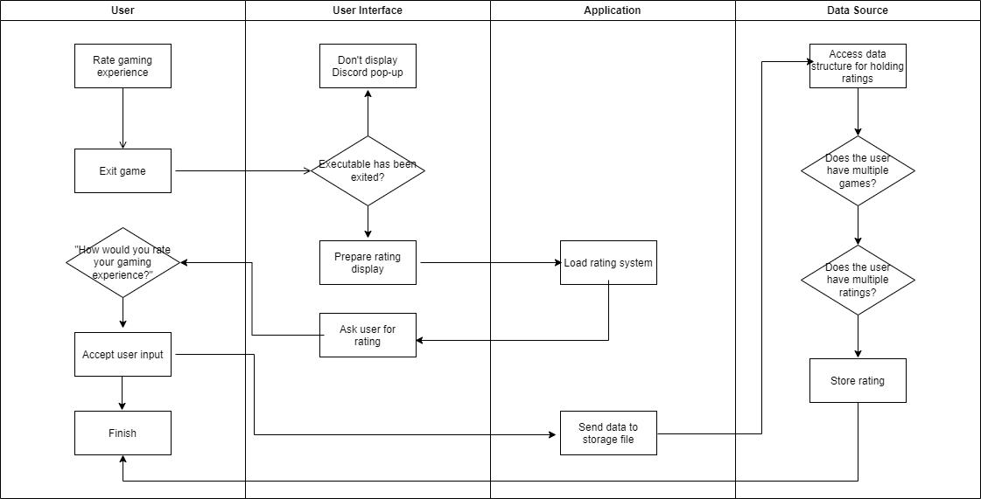

* As someone who plays with friends often, I want to be able to send recommendations/ratings to friends on the games I play.

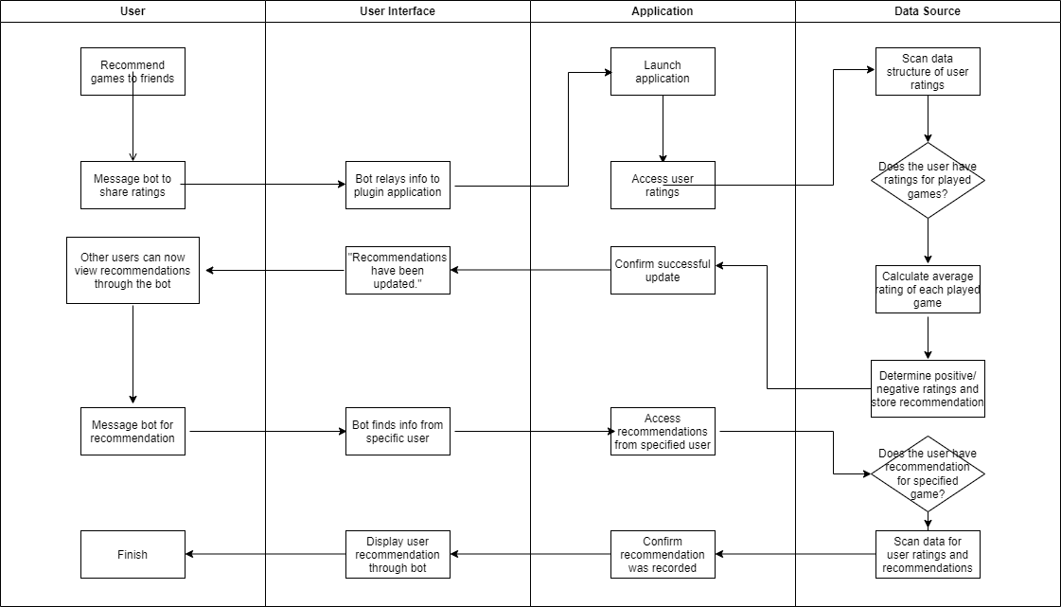

* When I’m looking for a game to purchase, I want to be able to command the bot to pull positive and negative reviews from the game’s Steam page.

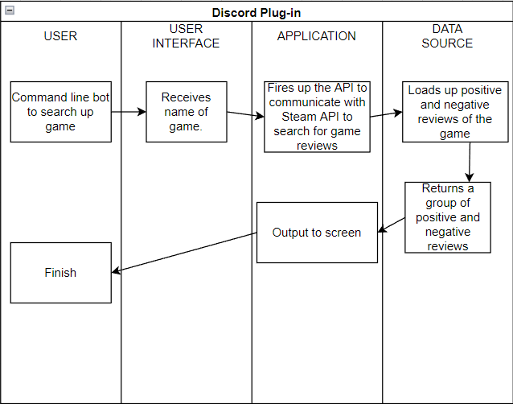

* Someone with this plugin can invite people to play a game on the discord text chat

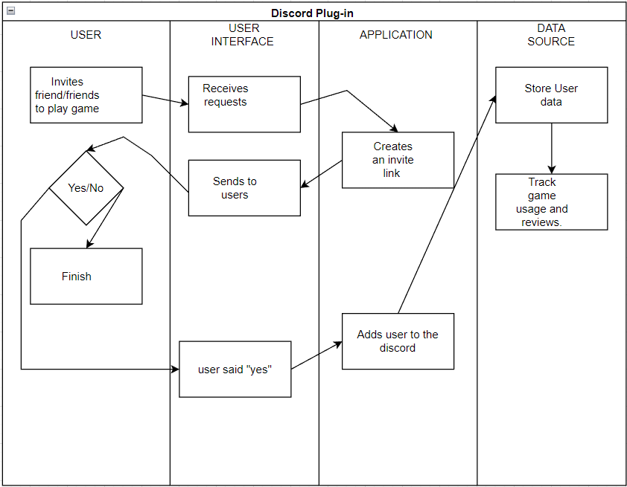

* As a avid player of a certain title, I want the ability to get notifications and track the game

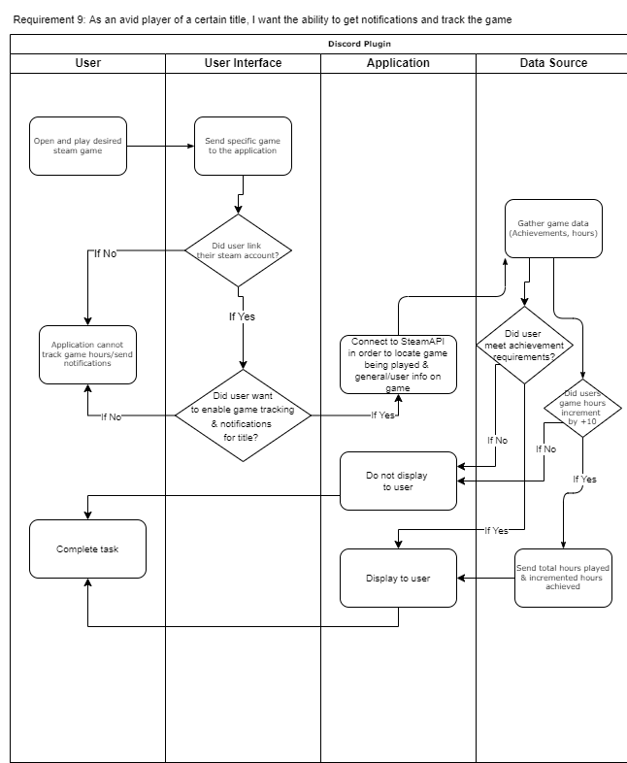

* As someone who plays games on a low budget, I want to be notified when a game goes on sale.

